Slepá mapa **POLOHA EURÓPY**

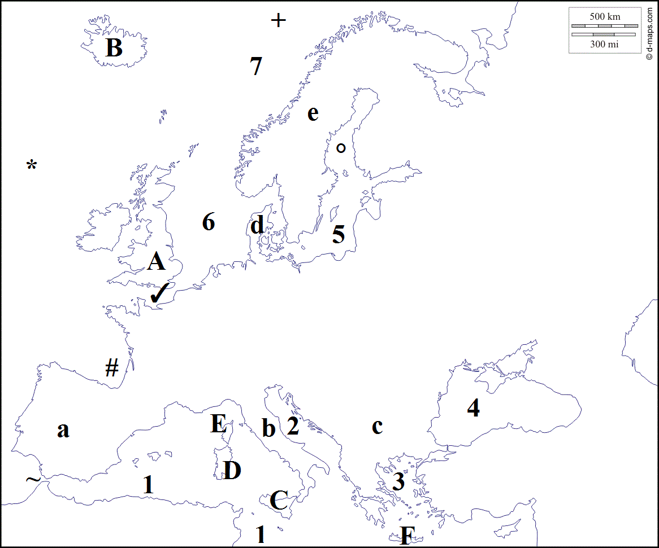**Oceány:**

* _____________________

+ _____________________

**Moria**:

1. _____________________
2. _____________________
3. _____________________
4. _____________________
5. _____________________
6. _____________________
7. _____________________

**Polostrovy**:

1. _____________________
2. _____________________
3. _____________________
4. _____________________
5. _____________________

**Ostrovy**:

1. _____________________
2. _____________________
3. _____________________
4. _____________________
5. _____________________
6. _____________________

**Prielivy**:

**~** _____________________

✓ _____________________

**Zálivy**: # _____________________ **°** _____________________